**Name: Tharindu Rehan Fernando Ponnahennedige**

**ID:22530478**

**Course: INFO601 Data Modelling & SQL/2401**

**UpLift Fit Database**

*Fernando Database Solutions*

*17th May 2024*

HEADING PAGE

* ERD Diagram 2
* Creation of Tables and Inserted Data 3-6
* Display the contents of each table 7-10
* Database Diagram 11

**ERD Diagram**

ERD Diagram From Assessment 1

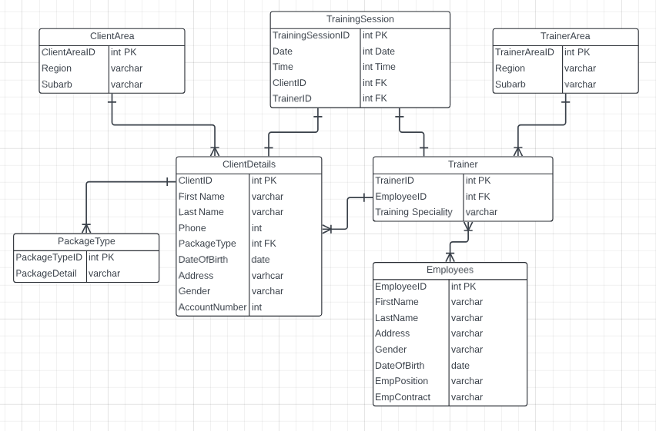

**Created Tables and Inserted Data**

Employees

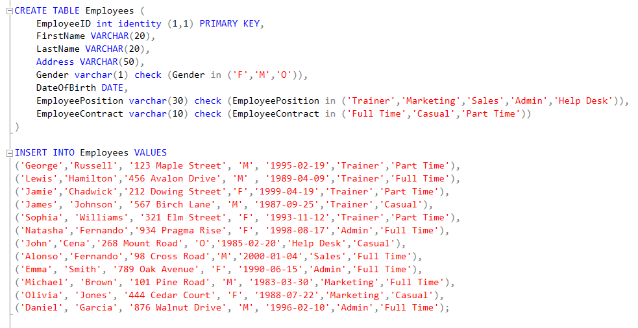

Package Type

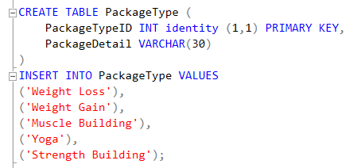

Clients

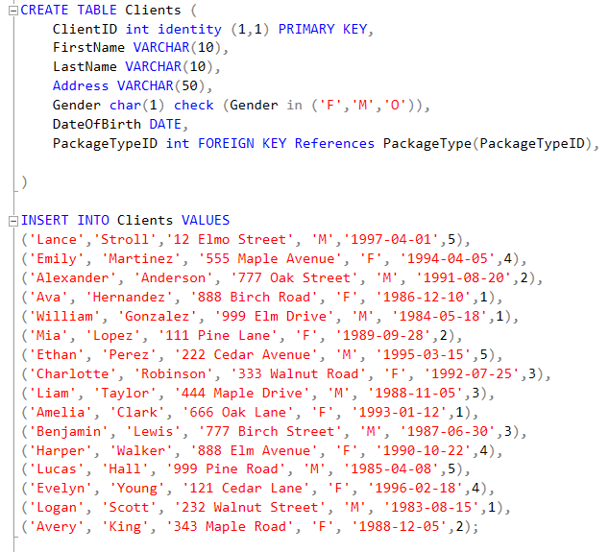

Trainer

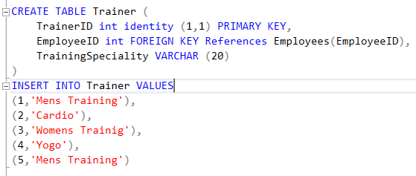

Client Area

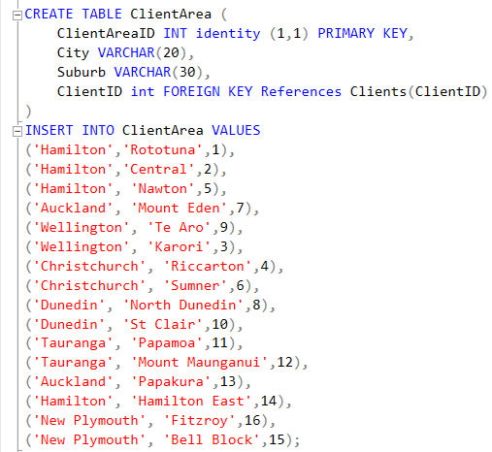

Trainer Area

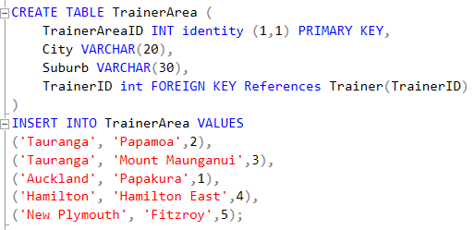

Training Sessions

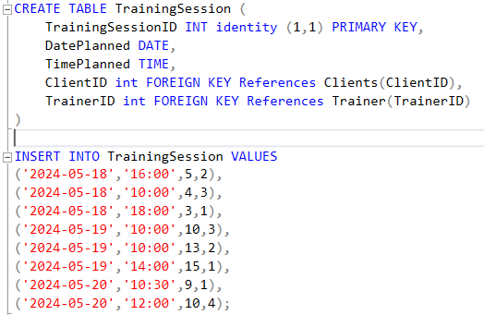

**Display the contents of each table**

Employees

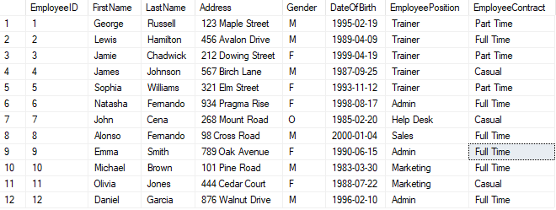

Package Type

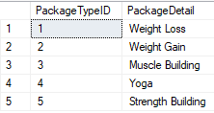

Clients

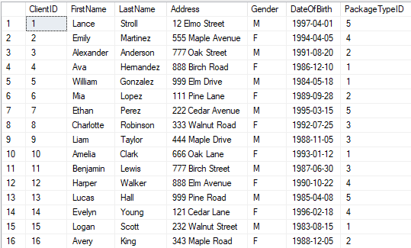

Trainer

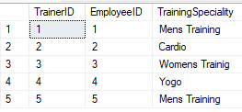

Client Area

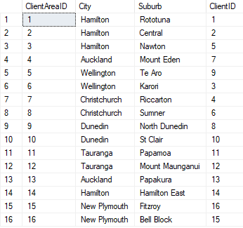

Trainer Area

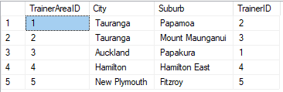

Training Sessions

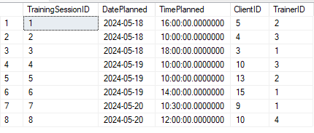

**Database Diagram**

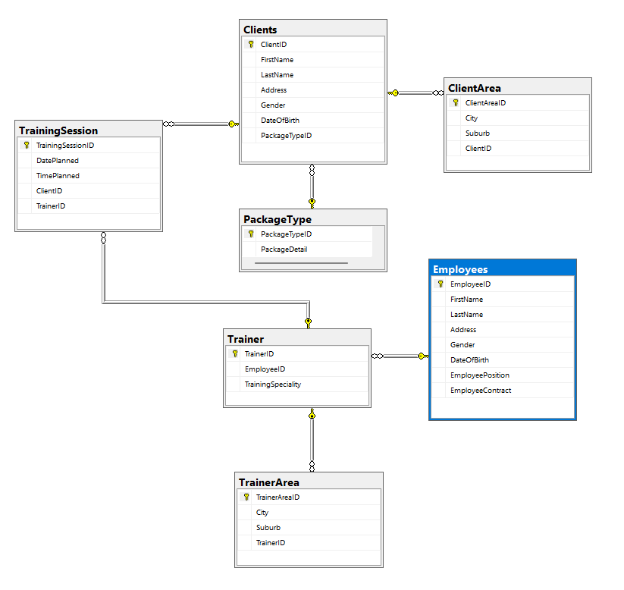

**THANK YOU**